Q.1

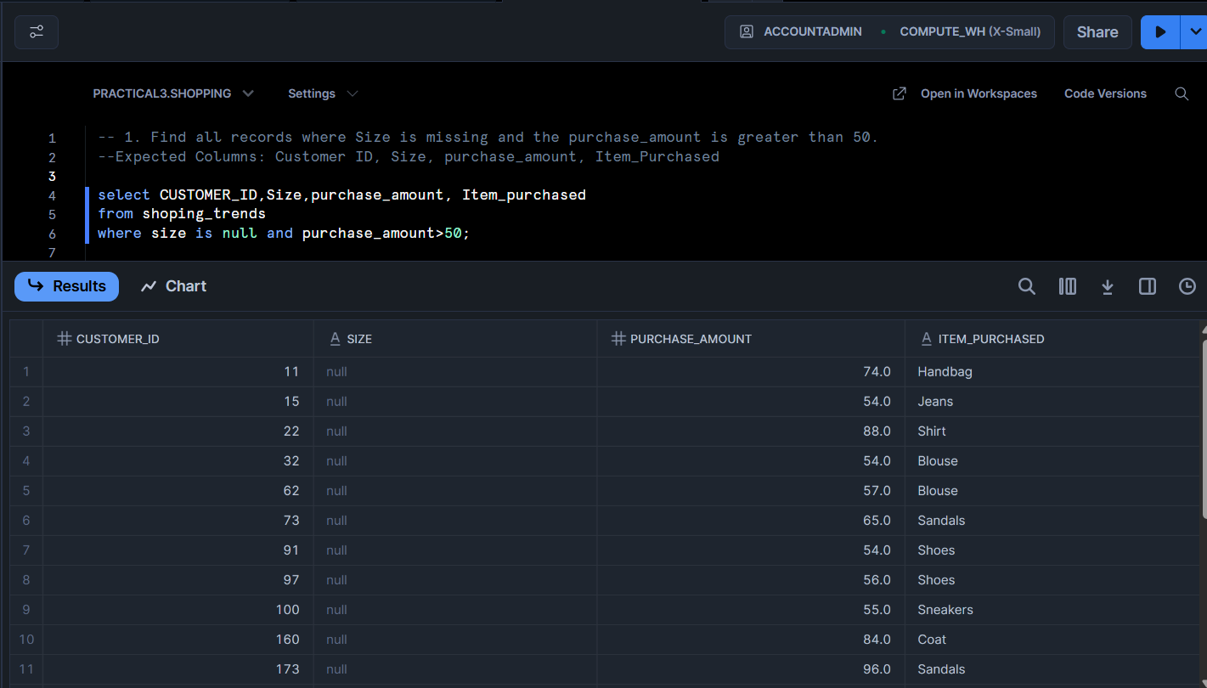

Q.2 Using IFNULL

Q.2 Using Coalesce

Q.3 Using IFNULL

Q.3 Using Coalesce

Q.4

Q.5 Using IfNull

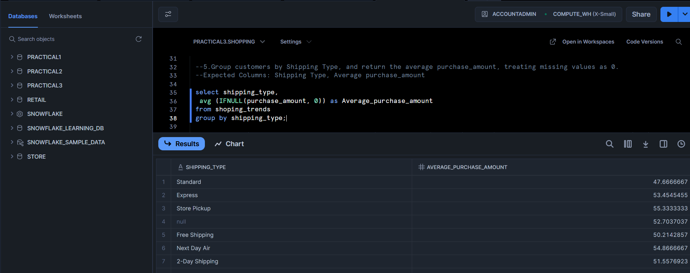

Q.5 Using Coalesce

Q.6

Q.7Using IFNULL

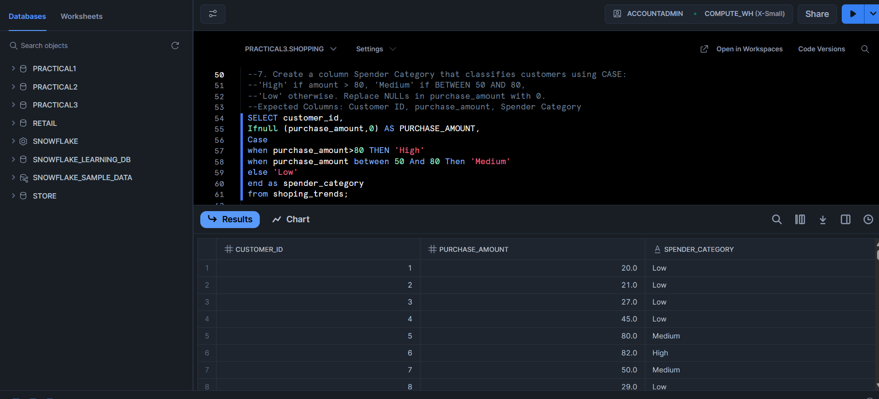

Q.7 Using Coalesce

Q.8

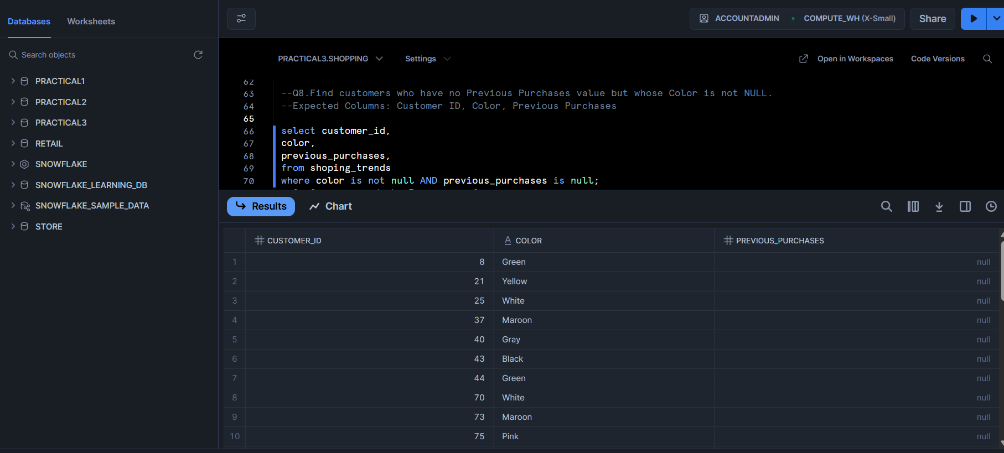

Q.9

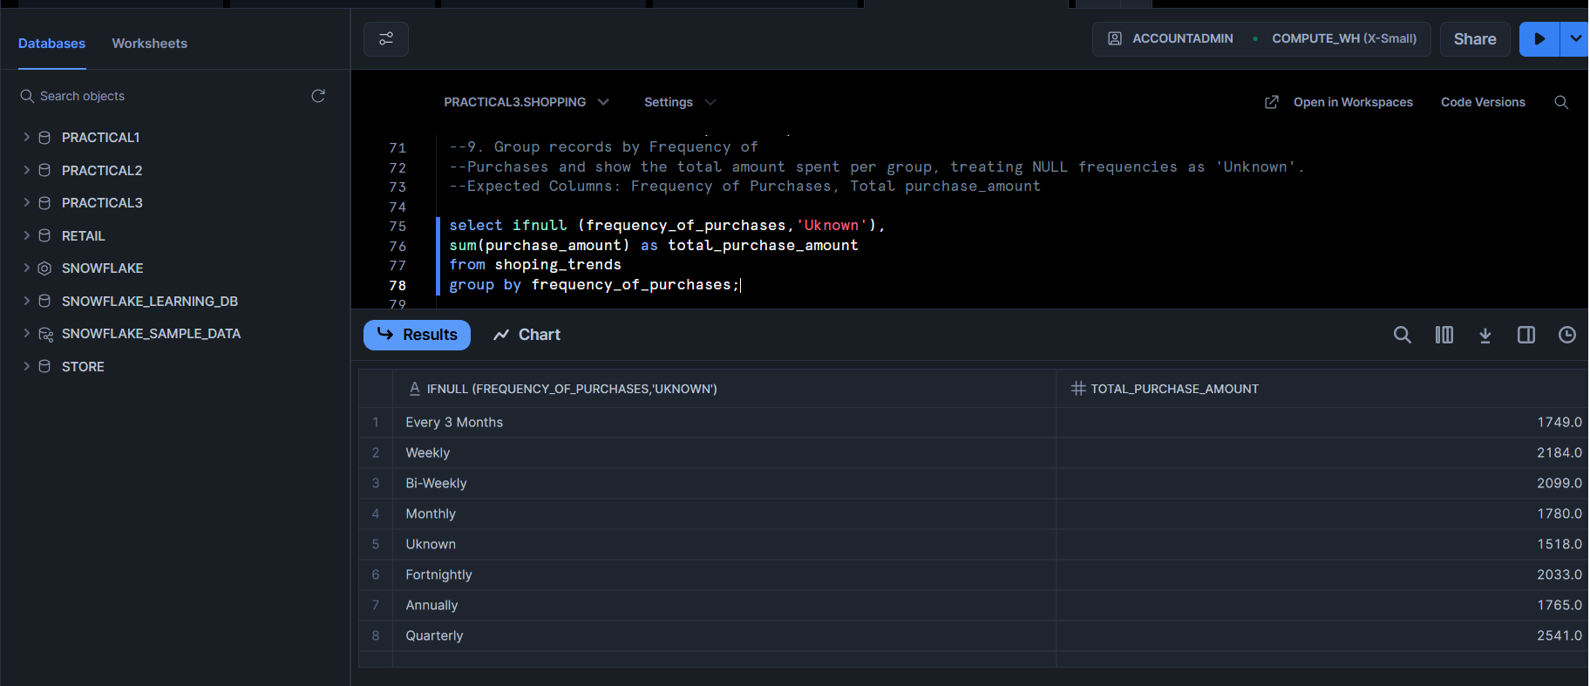

Q.10

Q.11

Q.12

Q13.

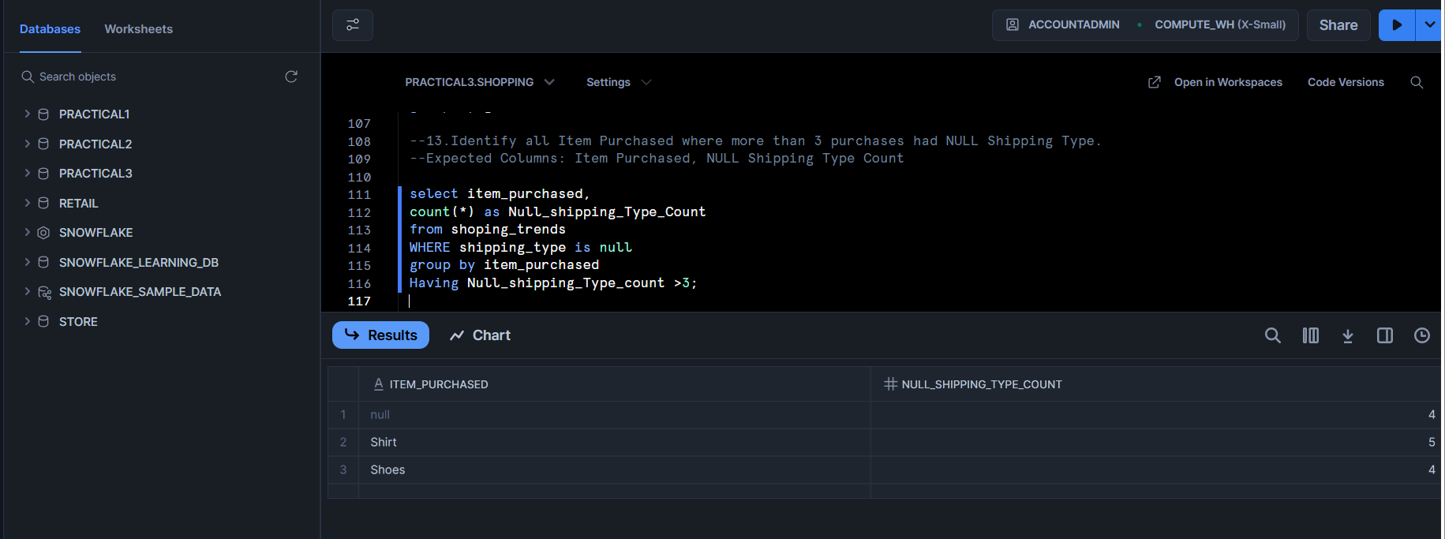

Q.14

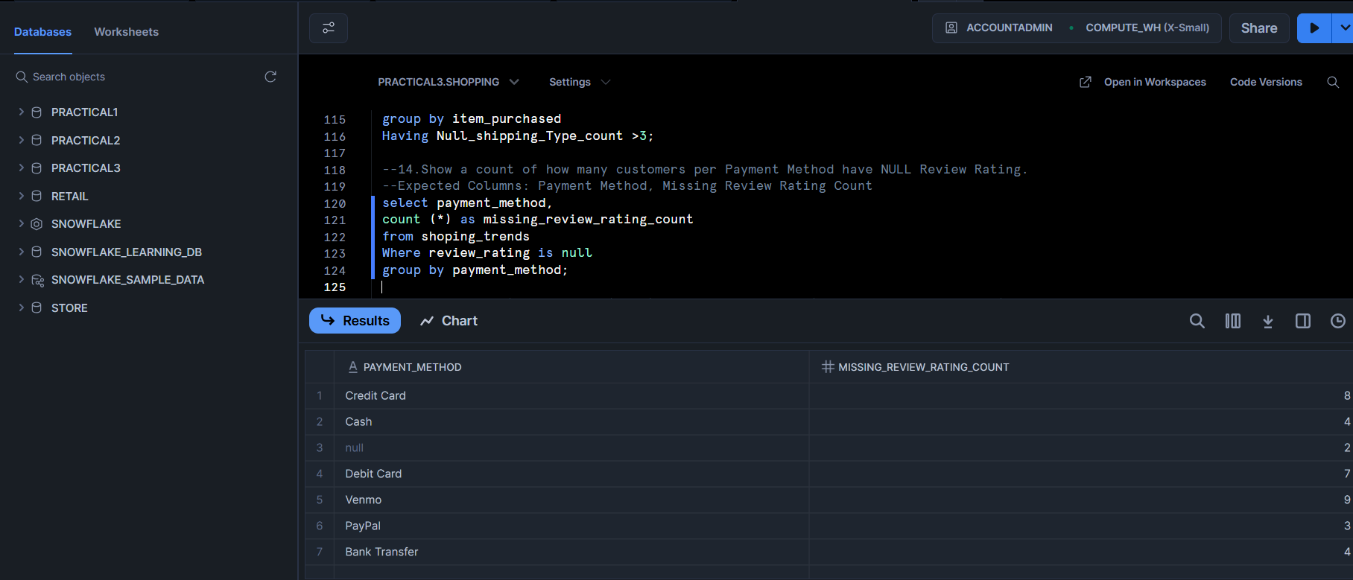

Q.15 Using ifnull

Q.15 Using Coalesce

Q.16

Q.17

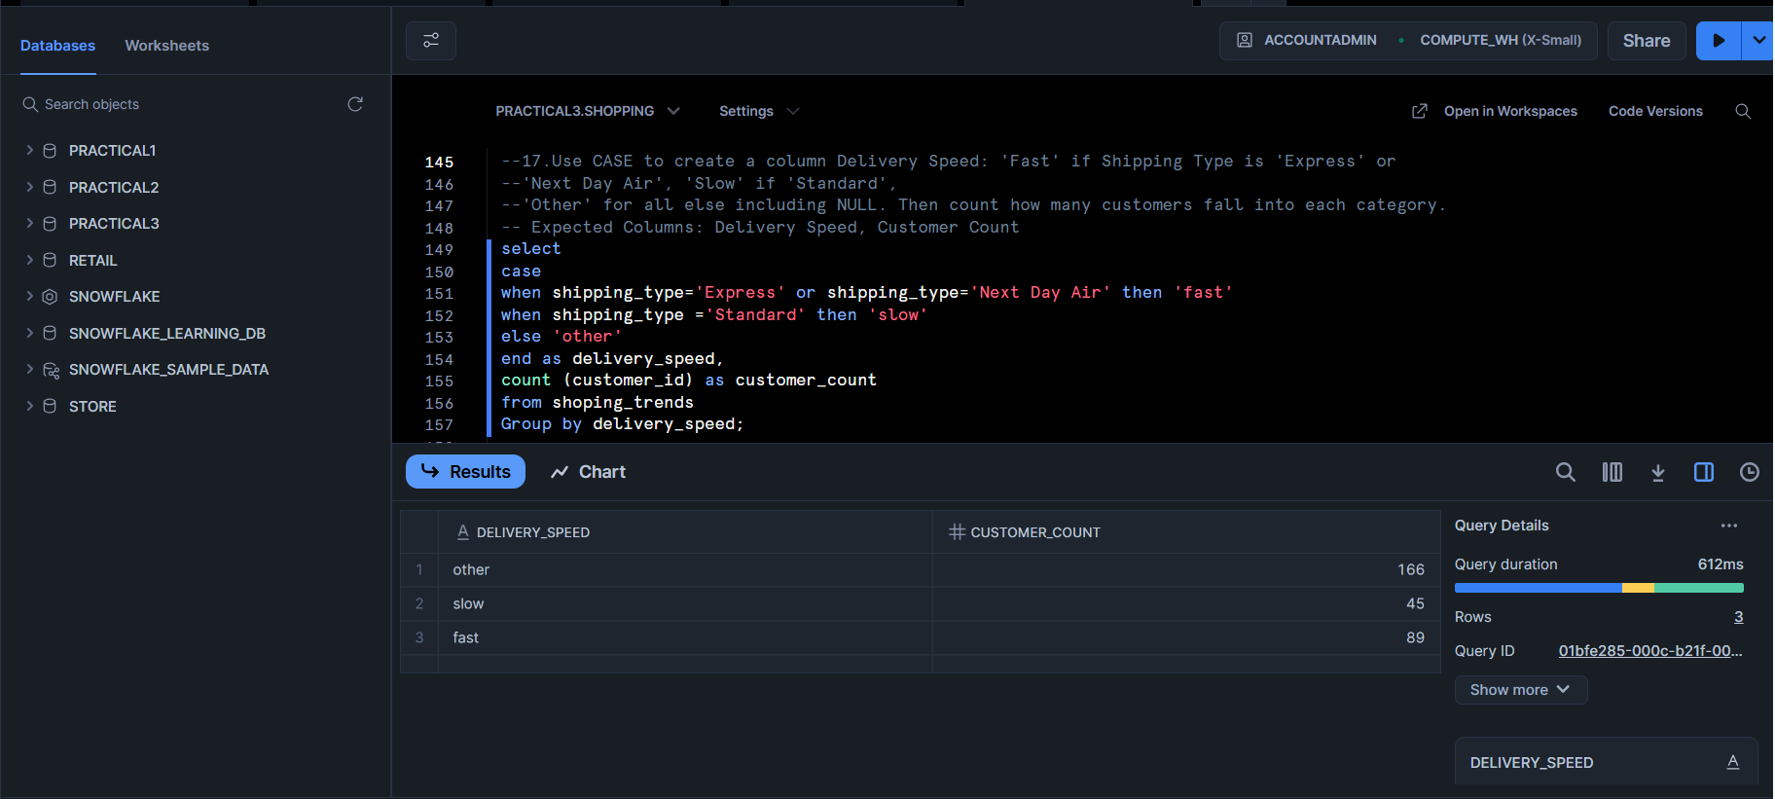

Q.18

Q.19

Q.20

